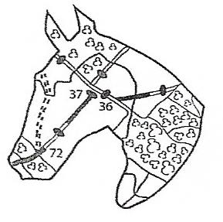
ESSEX BRIDLEWAYS ASSOCIATION www.essexbridleways.com

A Briefing Paper on the argument for more Bridleways

- Safety
Horse riders are vulnerable road users, 3000 accidents a year involve horses.
This costs the tax payer: police; ambulance; fire services, not to mention the costs to people’s lives and emotional wellbeing. If riders are on bridleways the costs are reduced
Safer routes for Horse riders also means safer routes for walkers and cyclists. The same benefits are provided for these vulnerable groups too.

- Economic issues
Horse owners, carers and riders in Britain spend more than seven billion pounds a year in gross output terms and provide 70,000 full time jobs with indirect employment comprising an additional 220,000 to 270,000 people. This especially enhances the rural economy

- Multiuser routes
Bridleways are in effect multiuser routes open to walkers, cyclists and the disabled. Economically it is more cost effective to provide bridleways than single use PRoWs

- Health benefits
Horse riding has both cardiovascular and muscle conditioning benefits for riders.
1 hours riding = 30 mins jog = cycle ride at 9mph.
It encourages young people to become self-sufficient, early risers, capable, caring active and healthy and interested in the environment.

- Tourism
Riding can encourage tourism. Horse tourism is a growing trend: walkers, riders and cyclists are attracted to an area that offers good scenery, good facilities and safe off road tracks. Essex is a tourist area but is limited by a lack of joined up multiuser routes for these user groups

- Increasing rider numbers especially of women and children
Riding is a growing area of activity: 3.5 million people have ridden in the last 12 months, an increase from 2.4m in 1999. Providing more off road riding would encourage this trend especially for women and children (73% of riders are women; 25% are under 16).

- Where to get more Information on Bridleway Issues:
Public Rights of Way Improvement Plan; The Equestrian Access Forum; British Equestrian Trade Association; Sport England Active People Survey; British Horse Industry Confederation; Women’s Support and Fitness Foundation; Countryside Agency; Department for Transport, Circular 01/2006; Department for Environment, Food and Rural Affairs; 2011; the National Planning Policy Framework; HASPST; BHS; DPROWAN

